FOR IMMEDIATE RELEASE:
Contact:
Jody Bikoff, CEO
Creative Clay, Inc.
727.825.0515
jody@creativeclay.org
www.creativeclay.org
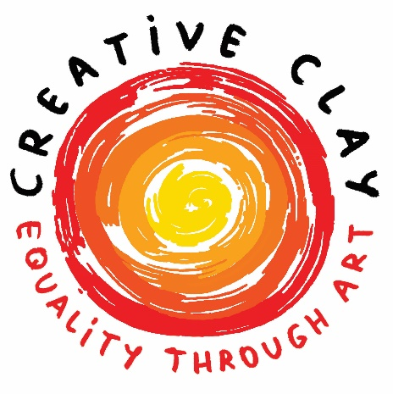

Creative Clay celebrates
World Art Day with new virtual exhibit

ST. PETERSBURG, Fla. – April 15 is World Art Day, an international celebration of the arts that promotes awareness of creative activity. The day also falls on Leonardo da Vinci’s birthday, an appropriate day to reinforce the links between artistic creations and society, encourage greater awareness of the diversity of artistic expressions and highlight the contribution of artists to sustainable development. The day also spotlights arts education in schools as a pathway to inclusive and equitable education.
Creative Clay will recognize World Art Day in April with A World of Art, its new virtual exhibit that celebrates creativity and the power of art.
“April's World Art Day inspired me to curate an exhibit that epitomizes the creative energy and activity that takes place at Creative Clay year-round,” said Jody Bikoff, Director of Exhibitions. “A World of Art honors the power of our artists as they create, sell and share their art in our virtual gallery, our Good Folk Gallery, the community and the world.”
A World of Art invites online gallery visitors to learn the stories of our artists, discover their rich, diverse work, and see how the viewing of art can spark imagination.
“A World of Art is an apt metaphor for Creative Clay and the power of art.” Bikoff said. “Entering both our online gallery and our physical space presents the visitor with an extraordinary folk-art collection. Our studios are always active with artists in the process of creating and exchanging ideas.”
UNESCO, The United Nations Educational, Scientific and Cultural Organization, supports World Art Day by promoting world peace and security through international cooperation in education, arts, sciences, and culture. Creative Clay recognizes that art nurtures creativity, innovation and cultural diversity for all peoples across the globe and plays a key role in sharing knowledge and encouraging curiosity and dialogue.
“Cleaning the Earth,” by Creative Clay Member Artist Lawrence J. is the highlighted image for the exhibit.
“I chose to feature the art of Lawrence J. for his imaginative narrative style and his affinity to use the world as a symbol in his artwork,” said Bikoff.
View A World of Art at www.creativeclay.org,, choose the “Gallery” tab. All works in this exhibit are for sale, with Creative Clay member artists receiving 50% commission on sales.
Creative Clay’s Virtual Gallery also includes the artwork of many of Creative Clay’s member artists. All artwork is for sale through its online gallery at creativeclay.org.
About Creative Clay
Creative Clay's mission is to help people with disabilities achieve full and inclusive lives by providing expressive, educational and vocational experiences in the arts.
Creative Clay’s core program is its Community Arts Program, which serves 50-60 adult artists with neuro-differences each week. Creative Clay's other programs include the Artlink apprenticeship program, Creative Care arts in wellness outreach program, and its Pinellas County Schools’ partnership Transition program.
Learn more about Creative Clay, its vision of equality through art, and its programs at www.creativeclay.org. Like Creative Clay on Facebook, follow on Instagram @creativeclaystpete; follow on Twitter @creativeclay and on LinkedIn.
###

